|  |
| --- |
| it’s a Jungle Out There |
| Assignment 01 |
| **[Man vs Wendigo]** |
| Version #01  All work Copyright © 2012 by Its A Jungle Out There Games.  All rights reserved. |
| **[Ibrahim Natchee]** |
|  |

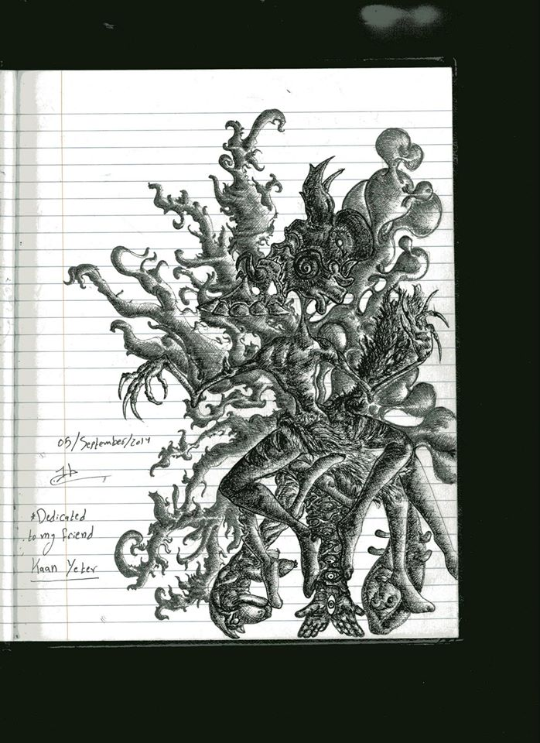

|  |
| --- |
| August 21 2016 |

**[Table of Contents](Man%20vs%20Wendigo.docx)**

Table of Contents

Version History…………………………………………………………………………………………………………………………Page 3

Game Overview………………………………………………………………………………………………………………………..Page 4

Game Play Mechanics………………………………………………………………………………………………………………Page 4

Controls……………………………………………………………………………………………………………………………………Page 4

Interface Sketch……………………………………………………………………………………………………………………….Page 4

Menu and Screen Description…………………………………………………………………………………………………..Page4

Game World ……………………………………………………………………………………………………………………………Page 5

Levels……………………………………………………………………………………………………………………………………….Page 5

Characters………………………………………………………………………………………………………………………….……Page 5

Enemies………………………………………………………………………………………………………………………………..…Page 5

Weapons……………………………………………………………………………………………………………………………….…Page 5

Story index…………………………………………………………………………………………………………………………..…..Page 5

Future Features………………………………………………………………………………………………………………….….…Page 5

**Version History**

[This is where you keep track of the detailed changes made to your document throughout the course of development.]

1. **Game Overview**

*A man has to survive after his plane crashed in the middle of the forest. Make your decisions and ensure he withstand the cold, the beasts and most dangerously, himself.*

1. **Game Play Mechanics**

*Click your decisions and make the best choices through the click of a mouse*

1. **Controls**

*The game is using the mouse and the click button to move the slides and make decisions that will ultimately decide the player’s fate*

1. **Interface Sketch**

*(What does the game interface look like? Provide a screen shot or sketch)*

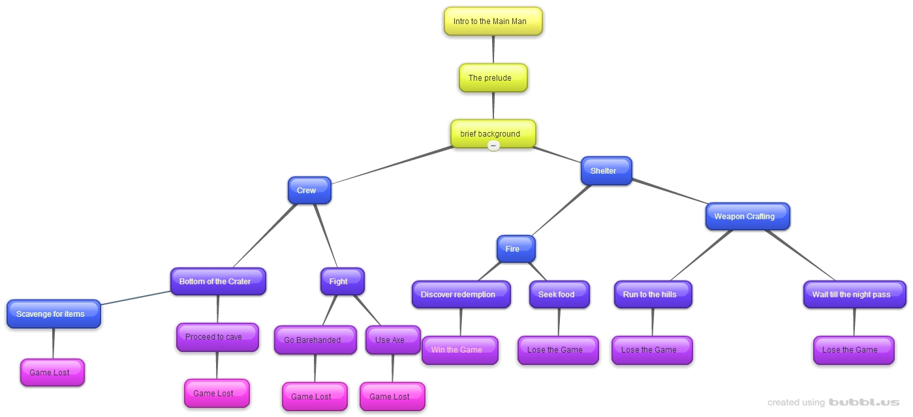

1. **Menu and Screen Descriptions**

*Additional Screen include a brief history into the character and his dilemma, intriguing the reader and getting him/ her invested in the story*

1. **Game World**

*The setting of the story takes place in the forest*

1. **Levels**

*There are different setting within the forest such as the cave, the bottom of the crater, each packed with decisions and critical factors that will decide the outcome of the player*

1. **Game Progression**
2. **Characters**

*Jonathan Hills is an ex con seeking to correct his life after a mistake he has done, he has to prove to himself that he has what it takes to make amends, or he will be forgotten.*

1. **Enemies**

*Enemies are behind each decision as Jonathan has to avoid Leopards, Bears, and Boars, as well keeping himself alive from the cold.*

1. **Weapons**

*Weapons are not a primary indicator of survival as some of Jonathan’s enemies are the best hunters in the animal kingdom. The weapons range from an Axe to his wits and fists. The true conclusion draws when he confronts himself.*

1. **Story Index**

*Jonathan Hills did his time and must confront himself before he is set out to the world, is he ready to change or is he going to repeat the mistakes of the past? A true test lies ahead of him as he is stranded in a forest with foes at every turn.*

*Every man must prove to himself what he has to fight for.*

1. **Future Features**

*Pictures and soundtracks with narrative voice is in the works to be included as the story could be expanded and unfold as the reader goes through different chapters.*